Lab Report

Your Information
Your Name: Joshua Zimmerman-Gibson
Assignment Title: Efficiently Storing Data with Amazon Athena

Screenshots
Connected to EC2 Instance
Connected to an EC2 Instance and opened a command shell.
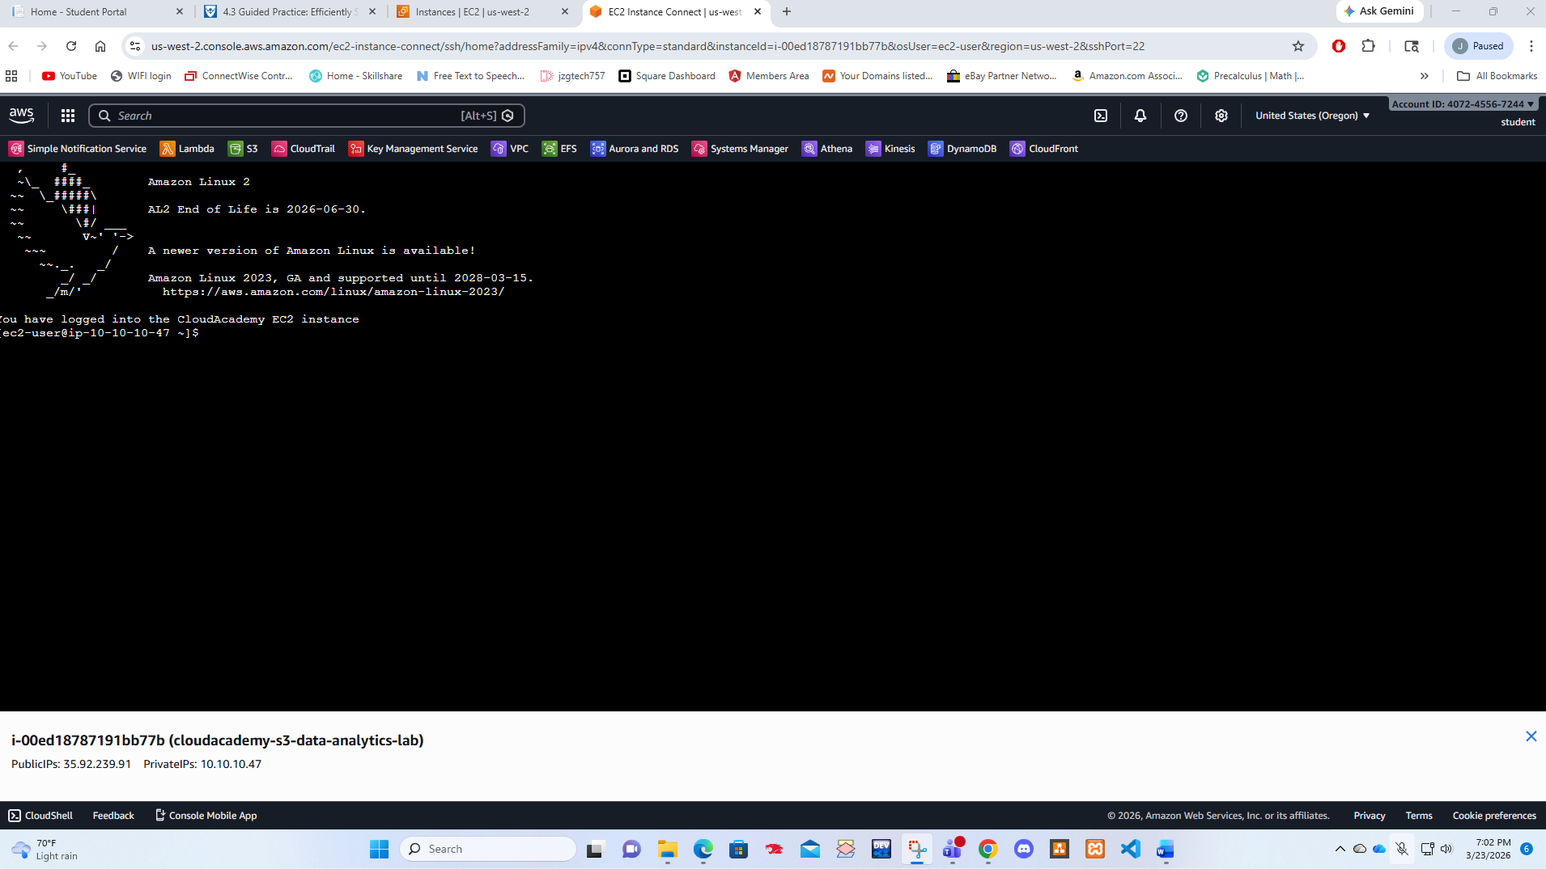
Created S3 Bucket
Used the EC2 Linux terminal to create an S3 bucket and copy files into it.
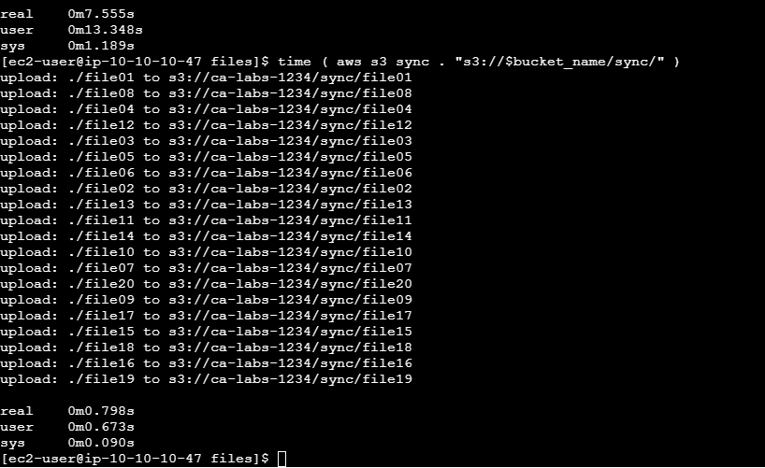
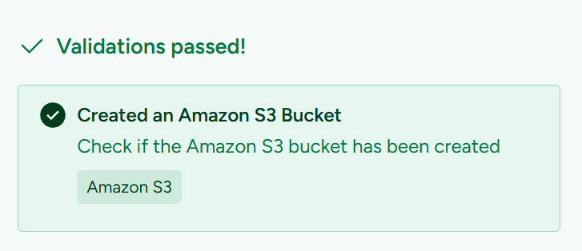
Queried Data with Amazon Athena
Used Amazon Athena to query data in an S3 bucket, then restructured the data to increase processing performance.
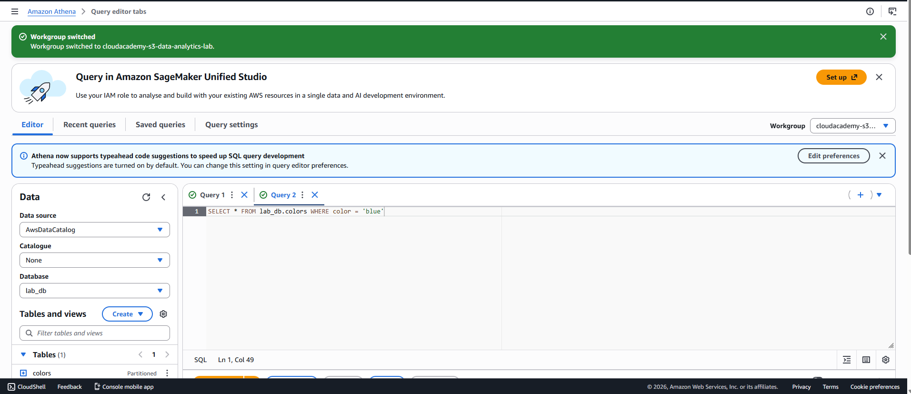

Convert Data into Parquet
Generated CSV data then converted it to the Parquet format. Used Athena to query the data and review performance metrics.
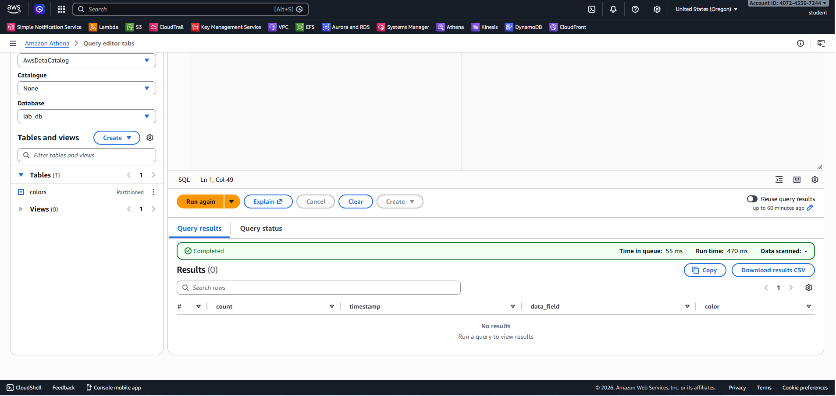
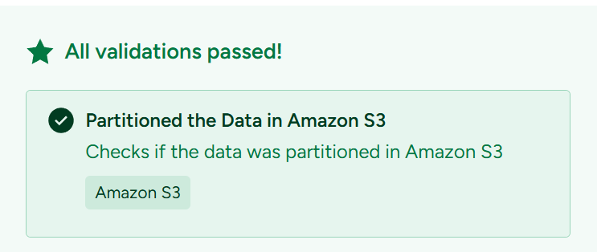
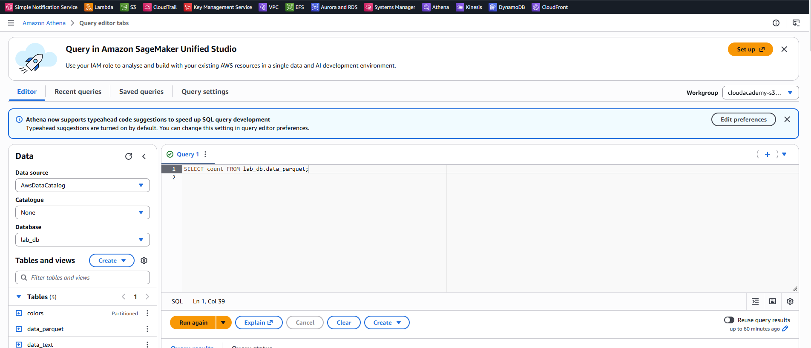
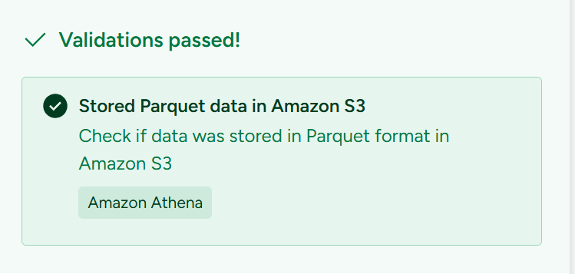
Compressed Data in S3 Bucket
Created data in JSON format, compressed the data using GZIP, then queried the compressed data using Athena.
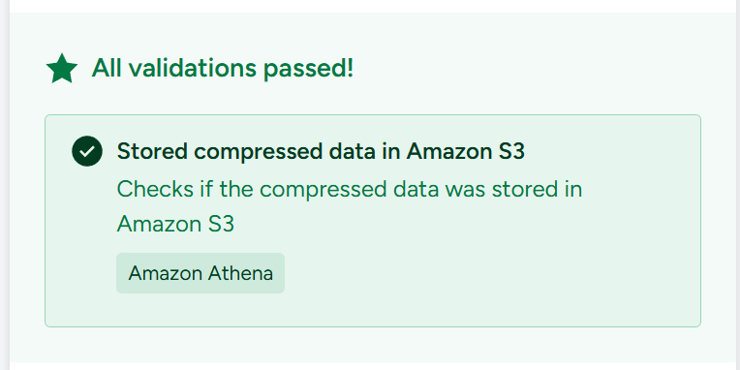
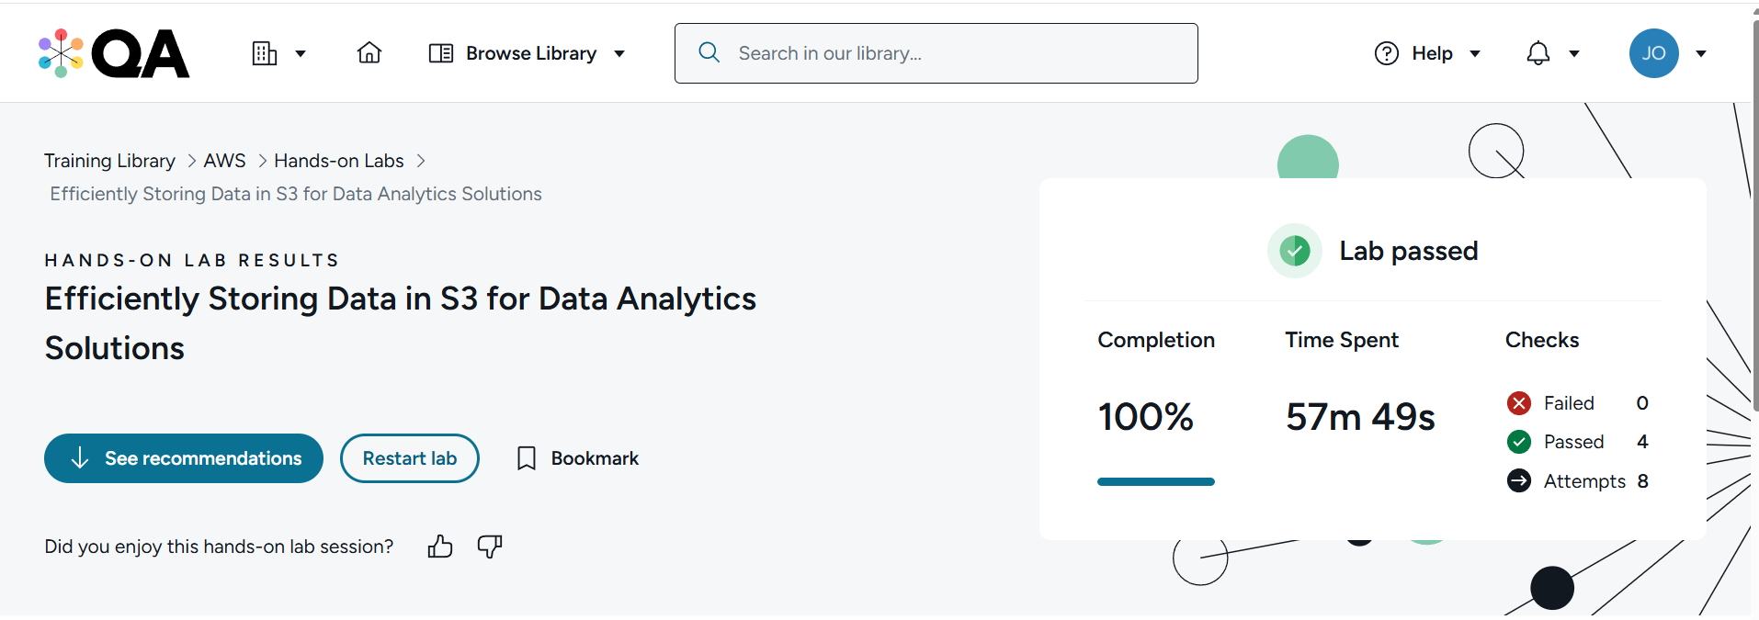

Questions
- What is parallelism and how does it affect data processing?
Parallelism means doing many tasks at the same time instead of one-by-one.
In data processing, this helps jobs finish much faster, especially when working with large datasets.
Think of it as having many people sorting papers instead of just one, the work gets done quicker.

- What is partitioning, and how does it affect the querying experience?
Partitioning means splitting your data into smaller groups based on a value like date, region, or category.
When your data is partitioned, a query only looks at the parts it needs, not the whole dataset.
This makes queries faster and cheaper, because less data has to be scanned.

- How does converting data into Parquet format increase storage efficiency?
Parquet is a columnar storage format, meaning it stores data column by column, not row by row.
This allows it to:
- Compress data better, using less storage
- Read only the columns needed for a query, which speeds things up
- Improve performance in tools like Athena and Spark
So overall, Parquet files are smaller, faster, and more efficient than CSV or JSON files.

